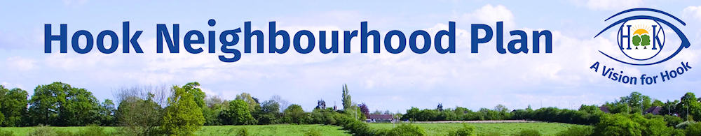

The Hook Neighbourhood Plan is nearly complete, as it is at the Regulation 14 Stage. This means that following this formal consultation the Plan will be submitted to Hart District Council for them to progress the Plan to Adoption, when it will become Planning Policy.

Comments from the previous consultation (Jan 18) have been incorporated into the plan or passed to the relevant Authority.

To help the Plan progress to the next stage, of the process, please give us your views on draft Hook Neighbourhood Plan (Nov 2918)

NAME: The Whitewater Valley Preservation Society
email: ContactUs@WhitewaterValley.org.uk website: www.WhitewaterValley.org.uk

POSTCODE: RG27 8JA

- Do you support the Plan overall? (Delete as applicable) YES

If NO, please explain why is the space below?

- Please provide your comments on:

- The Plan overall
- The Policies HK1 – 15

Please include reference to any Figure number if relevant to your comment

COMMENT HERE or continue overleaf ….

The Whitewater Valley Preservation Society fully supports the Plan overall, recognising as it does the importance of the landscape, ecology and water quality of the high priority internationally rare chalk stream habitat of the River Whitewater and its valley.

In particular we support the Objectives of Chapter 8, Environment and Landscape in Hook’s Neighbourhood Plan. Furthermore, In the light of the Government’s recently published 25 Year Environment Plan, we would encourage strengthening the following objectives:

- Create, protect and restore flora, wildlife habitats and biodiversity across all parts of the Parish, from back gardens to the woodland, meadows, grass and heathlands – to add: rivers and designated sites of special scientific interest (SSSI) and of interest to nature conservation (SINC)

- Protect natural water sources, including the River Whitewater, from pollution - to add: Protect from pollution and enhance the quality of natural water courses, including the River Whitewater

/ continued overleaf …

As identified in Action Plan 1 of Hook Parish Local Biodiversity Action Plan Key Habitats - The River Whitewater and Floodplain – The river has been found to be ‘over-abstracted’. Furthermore, as identified by Riverfly Surveys undertaken for the Whitewater Valley Preservation Society in 2017 and repeated in 2018, the River Whitewater is currently failing to achieve “good ecological status” under the Water Framework Directive.

Policy HK3 – Protecting and Enhancing the Biodiversity of Hook
In the light of the evidence provided above by the Whitewater Valley Preservation Society, we support policy HK3 and recommend adding “ecological” as follows:

- Development adjoining the River Whitewater must contribute to the creation of a wide corridor of good quality habitat, including measures to ensure long term sustainable management of the site. Proposals that will detrimentally affect water flow and ecological quality will not be supported.

References
25 Year Environment Plan (2018) – selected Goals and Targets:
- Reducing the damaging abstraction of water from rivers and groundwater, ensuring that by 2021 the proportion of water bodies with enough water to support environmental standards increases
- Reaching or exceeding objectives for rivers, lakes, coastal and ground waters that are specially protected, whether for biodiversity or drinking water as per our River Basin Management Plans
- Restoring 75% of our one million hectares of terrestrial and freshwater protected sites to favourable condition, securing their wildlife value for the long term.
- Conserve and enhance the beauty of our natural environment, and make sure it can be enjoyed, used by and cared for by everyone … by:
- Safeguarding and enhancing the beauty of our natural scenery and improving its environmental value while being sensitive to considerations of its heritage.
- Making sure that there are high quality, accessible, natural spaces close to where people live and work and encouraging more people to spend time in them to benefit their health and wellbeing.

Riverfly Survey Results 2017, published by the Whitewater Valley Preservation Society.

